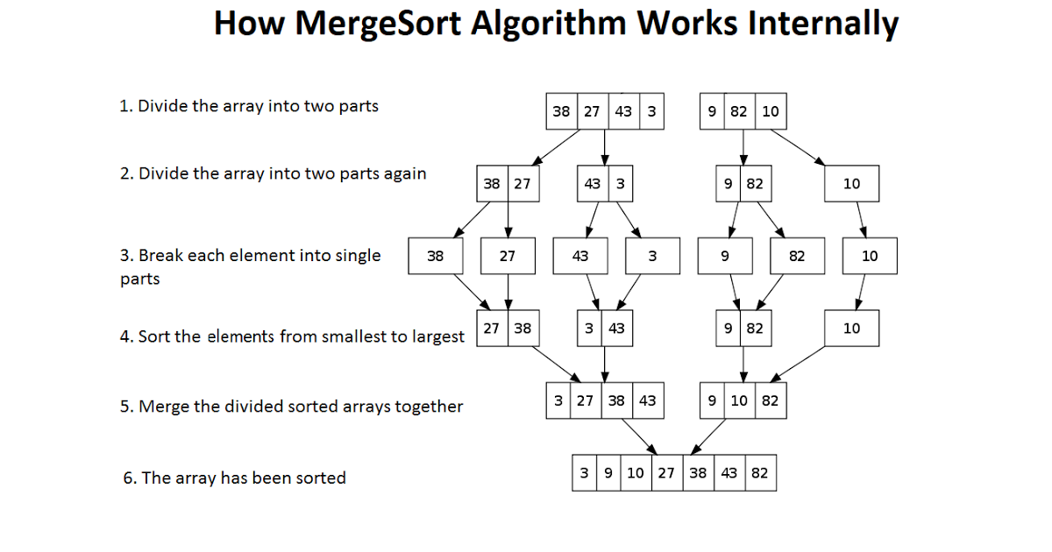

|  |  |  |  |  |  |  |  |
| --- | --- | --- | --- | --- | --- | --- | --- |
| 17 | 15 | 19 | 13 | 16 | 10 | 12 | 14 |